Introduction to Convolutional Neural Network (CNN)
A Convolutional Neural Network (CNN) is a type of deep learning model mainly used for image processing, computer vision, and pattern recognition tasks like:
- Image classification
- Object detection
- Face recognition
- Medical image analysis
CNNs are inspired by the human visual system and were popularized by Yann LeCun through the development of LeNet-5 for handwritten digit recognition.
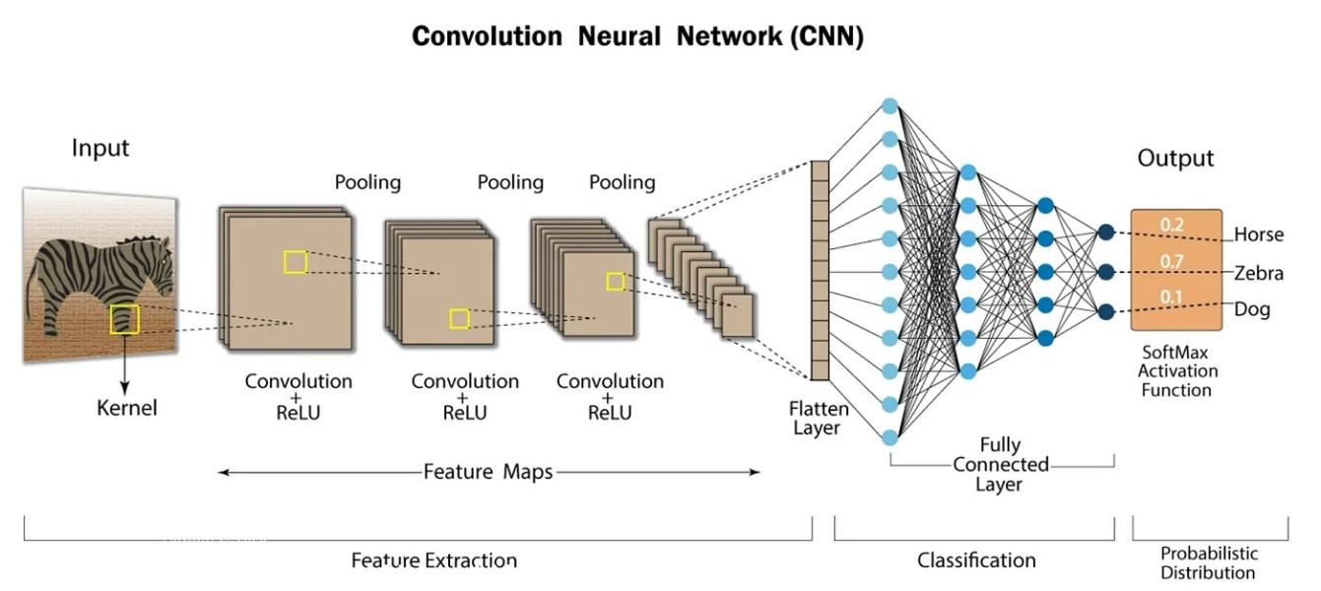

How CNN Works (Step-by-Step)
Suppose we input an image.
Step 1: Image as Matrix
An image is converted into a matrix of pixel values.
- Grayscale → 2D matrix
- RGB image → 3D matrix (Height × Width × Channels)
Example:
Image shape = 32 × 32 × 3

Step 2: Feature Extraction
CNN does not directly look at the full image at once.
Instead, it:
- Applies small filters (kernels)
- Detects patterns like edges, corners, textures
- Builds complex features layer by layer

Step 3: Classification
After extracting features:
- CNN flattens them
- Passes them to fully connected layers
- Produces final output (like cat/dog probability)

Layers of CNN

1️⃣ Convolutional Layer
What it does:
- Applies filters (kernels) to the image.
- Extracts important features.
How it works:
A small matrix (filter) slides over the image.
This process is called convolution.
Mathematically:
Output = (Image * Filter) + Bias
Important Terms:
- Kernel/Filter – small matrix (3×3, 5×5)
- Stride – how much filter moves
- Padding – adding zeros around image
- Feature Map – output after convolution
What it learns:
- First layer → edges
- Middle layers → shapes
- Deep layers → objects

2️⃣ ReLU Layer (Activation Layer)
Full form:
Rectified Linear Unit
Formula:
f(x) = max(0, x)
What it does:
- Converts negative values → 0
- Keeps positive values unchanged
Why we need it:
- Adds non-linearity
- Helps model learn complex patterns
- Prevents vanishing gradient problem (better than sigmoid/tanh)
Example:
Input: [-2, 3, -1, 5]
Output: [ 0, 3, 0, 5]

3️⃣ Pooling Layer
Purpose:
- Reduce spatial size
- Reduce computation
- Reduce overfitting
Types:
🔹 Max Pooling (Most common)
Takes maximum value from region.
Example:
2×2 region:
[1 3
4 2]
Output = 4
🔹 Average Pooling
Takes average value.

Why pooling is important:
- Makes model translation invariant
- Reduces parameters
- Speeds up training

4️⃣ Fully Connected Layer (FC Layer)
What it does:
- Takes flattened features
- Performs classification
Steps:
- Flatten feature maps
- Multiply with weights
- Apply activation (Softmax for multi-class)
Example:
Output: [0.1, 0.7, 0.2]
Prediction → Class 2

Complete CNN Flow (Summary)
Input Image
↓
Convolution
↓
ReLU
↓
Pooling
↓
(Repeat Conv + ReLU + Pool multiple times)
↓
Flatten
↓
Fully Connected
↓
Output (Classification)

Why CNN is Better Than Normal ANN for Images
ANN | CNN
Fully connected | Local connectivity
Huge parameters | Parameter sharing
Overfits easily | More efficient
Ignores spatial info | Preserves spatial structure

Real World CNN Architectures
Some famous CNN models:
- AlexNet
- VGG16
- ResNet
- Inception
These are used in ImageNet competitions and real-world applications.

Training a Convolutional Neural Network
CNNs are trained using a supervised learning approach. This means that the CNN is given a set of labeled training images. The CNN learns to map the input images to their correct labels.
The training process for a CNN involves the following steps:
- Data Preparation: The training images are preprocessed to ensure that they are all in the same format and size.
- Loss Function: A loss function is used to measure how well the CNN is performing on the training data. The loss function is typically calculated by taking the difference between the predicted labels and the actual labels of the training images.
- Optimizer: An optimizer is used to update the weights of the CNN in order to minimize the loss function.
- Backpropagation: Backpropagation is a technique used to calculate the gradients of the loss function with respect to the weights of the CNN. The gradients are then used to update the weights of the CNN using the optimizer.

How to Evaluate CNN Models
Efficiency of CNN can be evaluated using a variety of criteria. Among the most popular metrics are:
- Accuracy: Accuracy is the percentage of test images that the CNN correctly classifies.
- Precision: Precision is the percentage of test images that the CNN predicts as a particular class and that are actually of that class.
- Recall: Recall is the percentage of test images that are of a particular class and that the CNN predicts as that class.
- F1 Score: The F1 Score is a harmonic mean of precision and recall. It is a good metric for evaluating the performance of a CNN on classes that are imbalanced.

Different Types of CNN Models
1. LeNet: LeNet developed by Yann LeCun and his colleagues in the late 1990s was one of the first successful CNNs designed for handwritten digit recognition. It laid the foundation for modern CNNs and achieved high accuracy on the MNIST dataset which contains 70,000 images of handwritten digits (0-9).
2. AlexNet: AlexNet is a CNN architecture that was developed by Alex Krizhevsky, Ilya Sutskever and Geoffrey Hinton in 2012. It was the first CNN to win the ImageNet Large Scale Visual Recognition Challenge (ILSVRC) a major image recognition competition. It consists of several layers of convolutional and pooling layers followed by fully connected layers. The architecture includes five convolutional layers, three pooling layers and three fully connected layers.
3. Resnet: ResNets (Residual Networks) are designed for image recognition and processing tasks. They are renowned for their ability to train very deep networks without overfitting making them highly effective for complex tasks. It introduces skip connections that allow the network to learn residual functions making it easier to train deep architecture.
4. GoogleNet: GoogleNet also known as InceptionNet is renowned for achieving high accuracy in image classification while using fewer parameters and computational resources compared to other state-of-the-art CNNs. The core component of GoogleNet allows the network to learn features at different scales simultaneously to enhance performance.
5. VGG: VGGs are developed by the Visual Geometry Group at Oxford, it uses small 3x3 convolutional filters stacked in multiple layers, creating a deep and uniform structure. Popular variants like VGG-16 and VGG-19 achieved state-of-the-art performance on the ImageNet dataset demonstrating the power of depth in CNNs.

Applications
- Image classification: CNNs are the state-of-the-art models for image classification. They can be used to classify images into different categories such as cats and dogs.
- Object detection: It can be used to detect objects in images such as people, cars and buildings. They can also be used to localize objects in images which means that they can identify the location of an object in an image.
- Image segmentation: It can be used to segment images which means that they can identify and label different objects in an image. This is useful for applications such as medical imaging and robotics.
- Video analysis: It can be used to analyze videos such as tracking objects in a video or detecting events in a video. This is useful for applications such as video surveillance and traffic monitoring.

Advantages
- High Accuracy: They can achieve high accuracy in various image recognition tasks.
- Efficiency: They are efficient, especially when implemented on GPUs.
- Robustness: They are robust to noise and variations in input data.
- Adaptability: It can be adapted to different tasks by modifying their architecture.
Disadvantages
- Complexity: It can be complex and difficult to train, especially for large datasets.
- Resource-Intensive: It require significant computational resources for training and deployment.
- Data Requirements: They need large amounts of labeled data for training.
- Interpretability: They can be difficult to interpret making it challenging to understand their predictions.

Convolutional neural networks and computer vision
Convolutional neural networks power image recognition and computer vision tasks. Computer vision is a field of artificial intelligence (AI) that enables computers and systems to derive meaningful information from digital images, videos and other visual inputs, and based on those inputs, it can take action. This ability to provide recommendations distinguishes it from image recognition tasks. Some common applications of this computer vision today can be seen in:
- Marketing: Social media platforms provide suggestions on who might be in a photograph that has been posted on a profile, making it easier to tag friends in photo albums.
- Healthcare: Computer vision has been incorporated into radiology technology, enabling doctors to better identify cancerous tumors in healthy anatomy.
- Retail: Visual search has been incorporated into some e-commerce platforms, allowing brands to recommend items that would complement an existing wardrobe.
- Automotive: While the age of driverless cars hasn’t quite emerged, the underlying technology has started to make its way into automobiles, improving driver and passenger safety through features such as lane line detection.

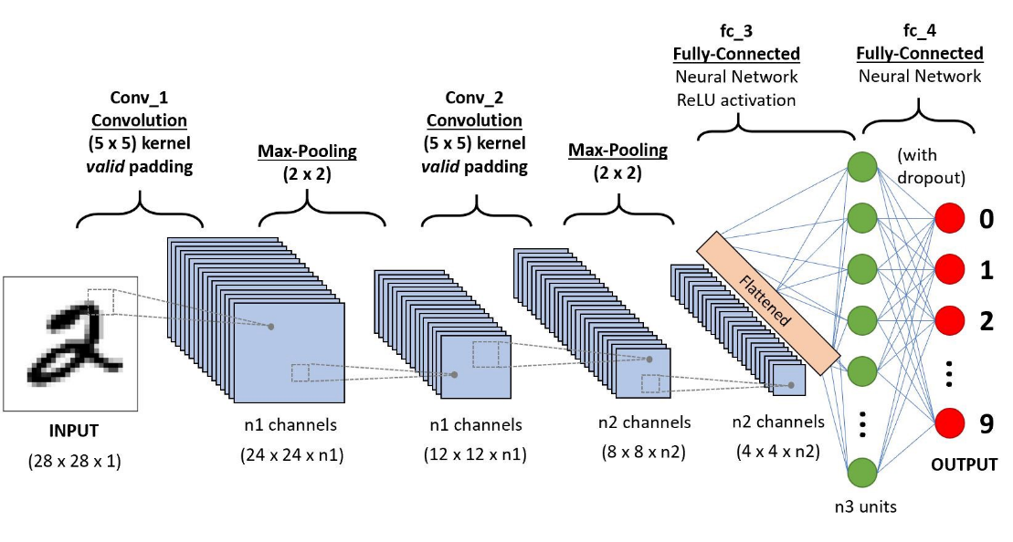
The diagram shows a Convolutional Neural Network (CNN) used for handwritten digit recognition (like MNIST dataset). The input is a 28×28 grayscale image, and the output predicts digits 0–9.
I'll explain the entire process step-by-step from left → right.

1️⃣ Input Layer
Input shape: 28 × 28 × 1
- 28 → height of image
- 28 → width of image
- 1 → grayscale channel
So the input is a single-channel grayscale image.
Example:
Image size = 28 × 28 pixels
Channel = 1
Tensor shape:
(28, 28, 1)

2️⃣ First Convolution Layer (Conv_1)
Kernel size:
5 × 5
Padding:
valid padding
Meaning:
- No extra pixels are added around the image.
Stride (default):
1
Output size formula
$$Output=(N-F+1)$$
Where
- N = input size
- F = filter size
So:
(28 − 5 + 1) = 24
Output size:
24 × 24
But CNN uses multiple filters.
Let number of filters = n1
Each filter produces one feature map.
So output becomes:
24 × 24 × n1
Meaning:
- n1 feature maps
- each map detects different patterns like:
  - edges
  - curves
  - strokes
- Example in TensorFlow/Keras:
- Conv2D(filters=32, kernel_size=(5,5), padding='valid')
- Here:
- n1 = 32
- Output becomes:
- 24 × 24 × 32

3️⃣ First Max Pooling Layer
Pooling size:
2 × 2
Pooling reduces spatial size.
Formula:
24 / 2 = 12
Output becomes:
12 × 12 × n1
Pooling keeps important features and removes less important information.
Example:
[2 5
7 3] → max = 7
So it reduces computation and prevents overfitting.

4️⃣ Second Convolution Layer (Conv_2)
Kernel size:
5 × 5
Padding:
valid
Input:
12 × 12 × n1
Output size:
(12 − 5 + 1) = 8
Number of filters = n2
So output:
8 × 8 × n2
This layer learns higher-level features like:
- corners
- digit shapes
- combinations of strokes

5️⃣ Second Max Pooling
Pooling:
2 × 2
Output:
8 / 2 = 4
Final feature maps:
4 × 4 × n2
Now the network has compact important features.

6️⃣ Flatten Layer
The 3D tensor is converted to 1D vector.
Input:
4 × 4 × n2
Flatten:
4 * 4 * n2 = 16n2
Example:
If
n2 = 64
Then
4 × 4 × 64 = 1024 neurons
So vector becomes:
(1024,)

7️⃣ Fully Connected Layer (fc_3)
This is a Dense layer.
Units:
n3 neurons
Activation:
ReLU
ReLU formula:
$$ReLU(x)=max(0,x)$$
Purpose:
- combine extracted features
- learn complex patterns
Example:
Flatten → Dense(128)

8️⃣ Dropout Layer
Dropout randomly turns off neurons during training.
Example:
Dropout = 0.5
Meaning:
50% neurons disabled randomly
Why?
- Prevent overfitting
- Improve generalization

9️⃣ Output Layer
Final dense layer:
10 neurons
Because digits:
0 1 2 3 4 5 6 7 8 9
Activation:
Softmax
Softmax converts outputs into probabilities.
Example:
[0.01, 0.02, 0.05, 0.80, 0.01, 0.02, 0.03, 0.02, 0.03, 0.01]
Prediction:
Digit = 3
Because highest probability = 0.80.

🔟 Final CNN Flow
Complete pipeline:
Input (28×28×1)
↓
Conv2D (5×5) → 24×24×n1
↓
MaxPooling (2×2) → 12×12×n1
↓
Conv2D (5×5) → 8×8×n2
↓
MaxPooling (2×2) → 4×4×n2
↓
Flatten
↓
Dense (n3) + ReLU
↓
Dropout
↓
Dense (10) + Softmax
↓
Digit Prediction

